DiGIR - Distributed Generic Information Retrieval
DiGIR defines a protocol for retrieving structured data from multiple, heterogeneous databases and to support distributed data retrieval across a loosely coupled federation(s) biological collections databases
- Protocol
  - Defines request and response message formats for communication between Provider and Portal
  - Assumes Providers conform to a known federation schema
  - Remains flexible to allow for federation schema pluggability
- Provider
  - Makes structured data available to portals
  - Communicates via protocol compliant messaging only
  - Complies with a known federation schema
  - Supplies meta-data to describe data classification and availability
- Portal
  - The entry point for a “user”
  - Can make requests of N number of providers
  - Communicates via protocol compliant messaging only
  - Queries registry for available providers
  - Can determine, based on provider meta-data, whether a provider should be queried
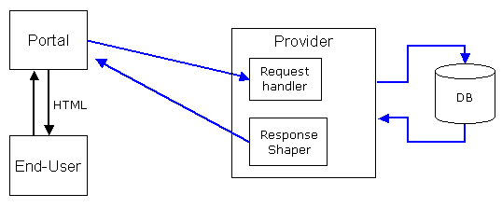
The Portal is made up of two components the Presentation and Engine. The Presentation is responsible for the creation of all the UI and send the requests to the engine to construct a DiGIR Query.
The Ecogrid implementation contains a web service component that translates from Ecogrid Queries to DiGIR Queries and then contacts the Engine. The responses go from the Engine back to the DiGIR/Ecogrid Web Service where they are translated into an Ecogrid Response. The Presentation component is not used by the Ecogrid.
